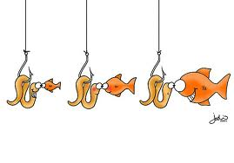 | HOOK – Something to lure them in! |  | LINE – images /audio you need |  | SINKER – text you require
Example Review | What built interest?  What grabbed your attention? |  | What were the key images?  How did audio effect the presentation of the images? |  | What are the key concepts expressed in the text?
Your own Review | What built interest?  What grabbed your attention? |  | What were the key images?  How did audio effect the presentation of the images? |  | What are the key concepts expressed in the text?
Your Book Tailer | What will build interest?  What will grab the attention of your viewers? |  | What will the key images be?  What will the key sounds be? |  | What are the key concepts expressed in the text you will use?
HOOK – Something to lure them in! |  | LINE – images /audio you need |  | SINKER – text you require

